Section 1.2 3,6,11,17,22,36,43,44;
Section 1.3 2efgh,8,9defghij,18cdef,25bcd
Deadline: Jan 24

Section 1.2 3
Section 1.2 6
Section 1.2 11
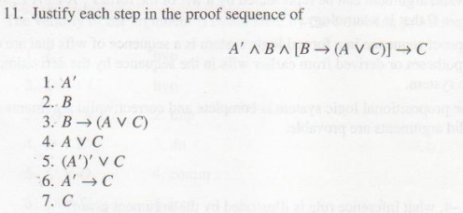
Section 1.2 17
Section 1.2 22
Section 1.2 36
Section 1.2 43
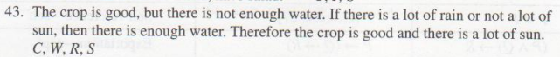
Section 1.2 44

Section 1.3 2efgh
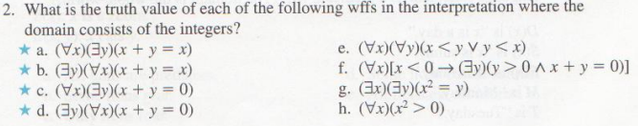
Section 1.3 8
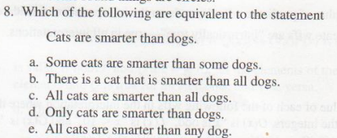
Section 1.3 9defghij
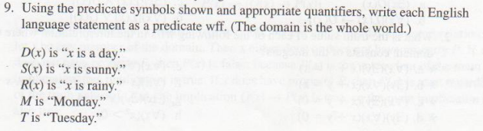
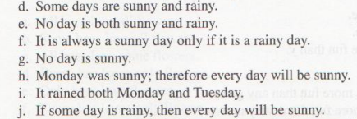
Section 1.3 18cdef
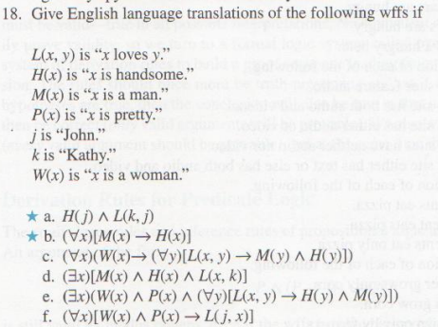
Section 1.3 25bcd
